Design:

1. ICON image - change the unity icon image
2. 'Made with Unity' starter screen – remove
3. Nice start page and background
4. Nicer design for the Alert windows
5. Insert Logo image

Others:

1. add three vertical lines (menu) icon at the start screen:
   1. 'Help': Text (editable text by me)
   2. 'Settings' option:
      1. Options of boards
         1. Current (wood)
         2. Blue

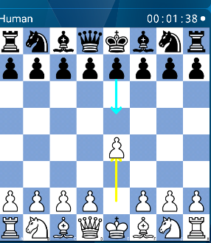

* + - 1. Green

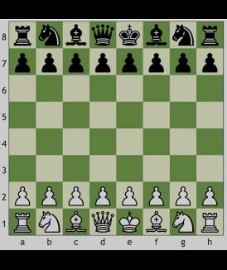

* + - 1. Grey

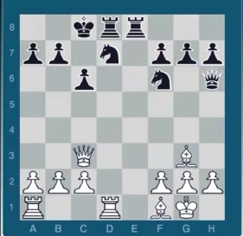

* + 1. Sounds (on/off)
    2. Show legal moves (on/off)
    3. Rate this app

1. **start screen: ‘Libraries’:** 
   1. **add the ‘trainer’ icon next to the ‘+’**
   2. **when the trainer icon is tapped go into trainer display (same as when hold tap on any library but no library is selected)**
2. **When in Libraries or Lines: when into trainer mode selection, the + can be invisible (only show trainer, edit, delete if single selection or trainer and delete if multiple selection)**
3. **Case sensitivity is enabled for library and line names:**
   1. **FIX: disable case sensitivity (for example: FRENCH = French = frEnCh) and should alert a ‘duplicate name’**
4. Same lines names are allowed in different libraries:
   1. FIX: Allow same line names in different libraries example:
      1. French/MainLine
      2. Spanish/MainLine
5. **When in play mode show the names of library as well on top i.e. (Spanish, Morphy Defense)**
6. **When in Trainer SETTINGS show library name as well next to the line’s name (ie. Spanish/Morphy..)**
7. **When finishing a line – the alert will also add the library name of the next line.**
8. **when training add an arrow to skip to the next line**
9. when in play mode: if possible tapping on the notation will take you to that position so for example if 1.d4 d5 2.Nc3 Nc6 3.a3 a6 – if tapping on Nc3 will take you back to that position
10. when adding libraries and lines if they can get organised in alphabetic order
11. **in Training: if possible to display score “_out of _” on the bottom part and keep updating and also display the grand total score (from all lines) underneath.**

**No need to display the score again at the end of the line in the alert but if perfect score show: “Well done! You will now start …” if not perfect score for the line just show:” You will now start …”**

1. Sound doesn’t work on computer moves in the trainer

Sound should not work on incorrect moves

* If possible, please download ICC chess app for android and copy sounds from there (move sound is fine, but the check and capture sounds can be improved)